Identification of an Unknown-A
Yue Shu
11-28-20223
CHEM 2081-001
TA: Dominic Fico

Introduction:
The purpose of this formal laboratory report is to analyze and identify unknown compounds using nuclear magnetic resonance (NMR), mass spectrometry (MS), and infrared spectroscopy (IR). NMR, MS, and IR are all useful tools used by organic chemists to analyze organic compounds. By analyzing different data, compounds can be determined. Learning these skills will be of great help in the fields of chemistry and medicine. These methods will be used during examinations to assist doctors in diagnosis.

Body:
Nuclear magnetic resonance, also known as NMR, is one of the tools we use to identify unknown substances, which can determine the exact location of functional groups present in molecules. NMR can be used to determine atomic nuclei with odd mass numbers and/or odd atomic numbers. Radio frequency is used to flip atomic nuclei to higher energy states, and then release energy by observing signal attenuation that occurs over a period of time for measurement. The working principle of NMR is to apply a magnetic field and radio frequency to the sample. The atomic nuclei in the sample rotate and align with the magnetic field. When the nuclear spin falls back to a lower level, a signal is generated for NMR reading.

FTIR stands for Fourier transform infrared and is a type of infrared instrument. Its working principle is that when organic compounds absorb infrared radiation, specific bonds within the compound begin to exhibit vibrational excitation. Infrared light can separate the components of a mixture, making it easier to distinguish functional groups, triple bonds, double bonds, and single bonds. The energy difference required for molecules to move in certain ways is reflected in their different infrared absorption, which is recorded on a chart showing which light frequencies the sample absorbs. The graph can be analyzed to determine the functional groups present in the sample.

Mass spectrometry (MS) uses mass to determine the identity of a sample. The mass spectrometer will separate, detect, and determine ions based on their mass to charge ratio (m/z). Draw a graph of the relationship between relative ion flow (signal) and m/z, and generate a mass spectrum. By analyzing the images, the identity of the components in the sample can be determined.

Data:
HMR:
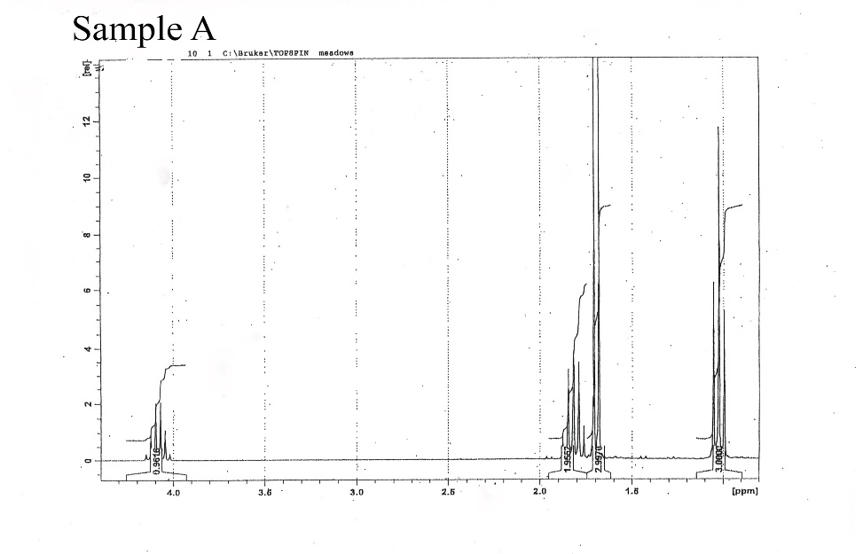
GCMS:
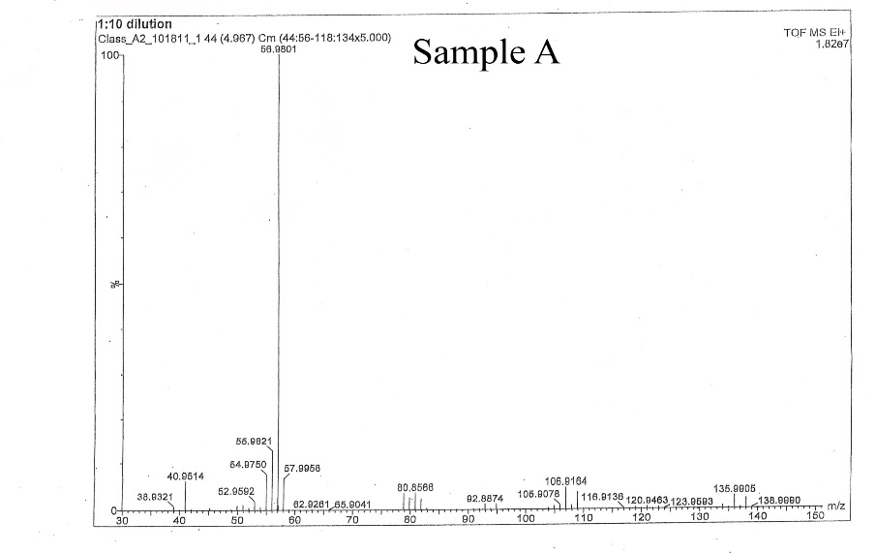
FTIR:
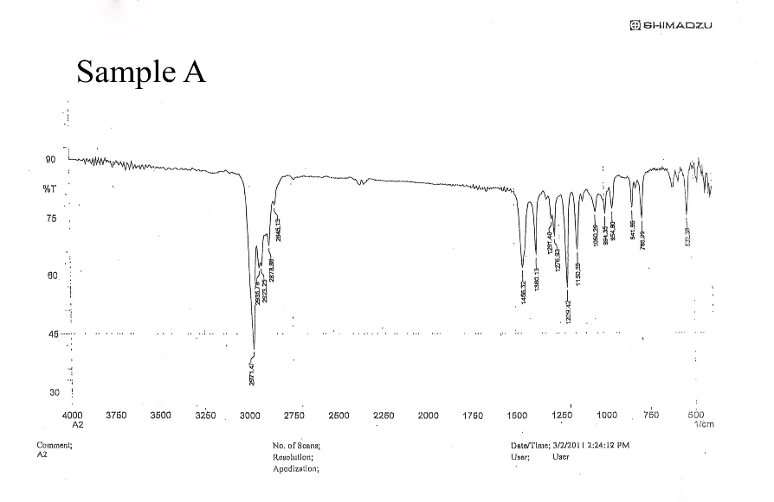

Analysis:
The first thing to focus on is NMR. There are four separate peaks indicating four hydrogen atom environments, and the compound we obtained is CHCHCHCHX. There are 6 peaks at 4.1 ppm, so there are 5 adjacent peaks. This may be a methyl group bonded with bromine.
2. From the FTIR spectrum, it can be seen that the maximum peak frequency is between 2750-3000 1/cm, which belongs to the range of alkanes (2850-3100=C-H) 1. There is a peak between 500-520 1/cm that belongs to the signal of halogens, especially bromine (500-600=C-Br). So it can be roughly determined that the compound contains Br element. So it can be determined that X in the first step is a halogen, and it is very likely to be Br.
3. The maximum peak on the right side of the GCMS chart is 138.00, so the mass of M+is 138 g/mol. It can be verified that the chemical formula is consistent with CH3-CH2-CHBr-CH3. It can be concluded that the compound indeed contains Br, and there is a very obvious peak at 56.9801 m/z to verify the existence of Br.

Conclusion:
The structure was determined to be 2-Bromobutane.

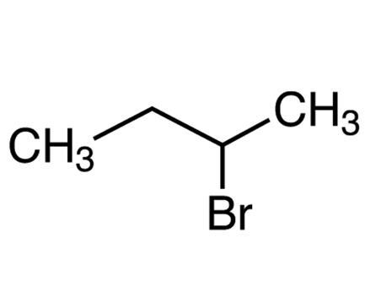

References:
References:
Keller, L., Ruychev, V., CHEM 2081 Organic Chemistry II Lab Manual. 2023 ed. Plymouth: Hayden-McNeil, 2023

